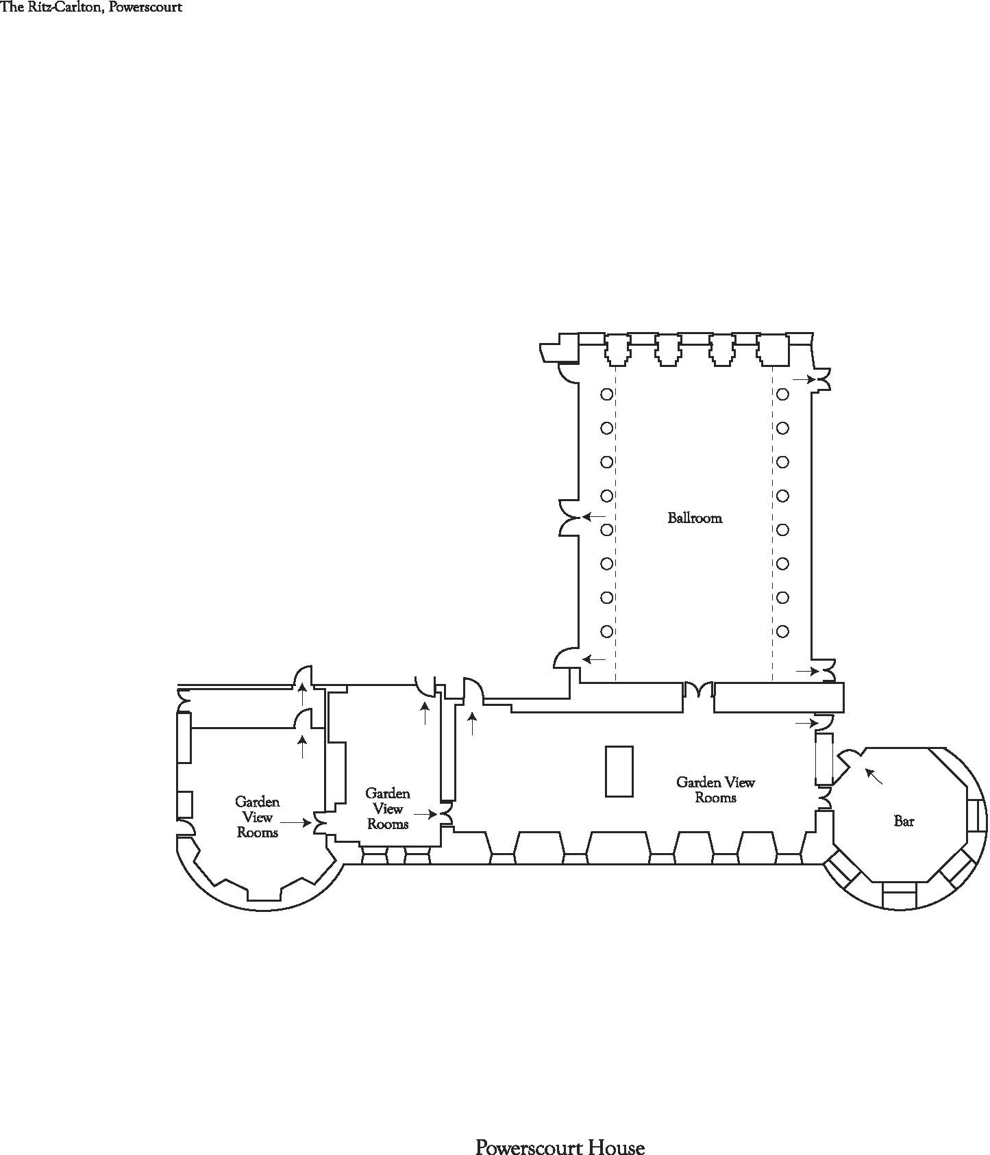
2
11
3
4
5
7
8
9
6
High Cocktail tables

Short Cocktail tables

Width between pillars 8.2m

Width between walls 12.1m/ 39.69ft Area = 132.84sqm

Length 16.2m/ 53 ft Area = 196.02sqm
(end pillar to end pillar)

Height 12m

